THE GREAT CHEESE HUNT

A NEW MICROMOUSE EVENT

TECHNICAL BULLETIN #3

PUBLICATION RIGHTS RESERVED

ADDRESS QUESTIONS TO:

DR. ANDREW R. SASS

IEEE, L.I. SECTION

arshacker@aol.com

IT IS ASSUMED THAT THE READER IS FAMILIAR WITH THE GREAT CHEESE HUNT - TECH BULLETIN #1 AND #2.

Pic 1 is a hand-wired board implementing the IR Beacon.

Pic 1

The Beacon in Pic 1 contains (starting from front right) a Proximity Sensor, RED LED and resistor, IR LED series resistor (200K Ohm trim pot\* dialed to 147K Ohm), GREEN LED and resistor, IR LED, and IR Sensor (for Option1). \*A source of trim pots is <https://a.co/d/4oS0ebS>

The Beacon also contains a Battery Box with two 3.7V li-ion batteries, a yellow ON-OFF button and a RESET button.

The dimensional placement of critical elements of the Beacon from the point of view, POV, of the Mouse is shown in Fig. 1

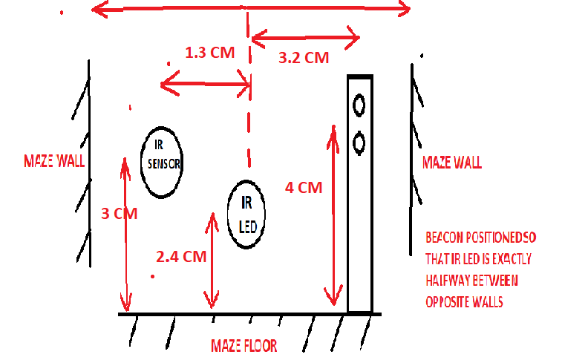Fig. 1

Pic 2 shows a board containing the IR portion of a “Mouse” called “Mouse Sim” and a Nano. This board simulates the Mouse interaction with the Beacon and is named “Mouse Sim”. Mouse Sim contains an IR Sensor and IR LED (for Option 1). Mouse Sim can be programmed for either Option 1 or Option 2 as described in Tech Bulletin # 1.

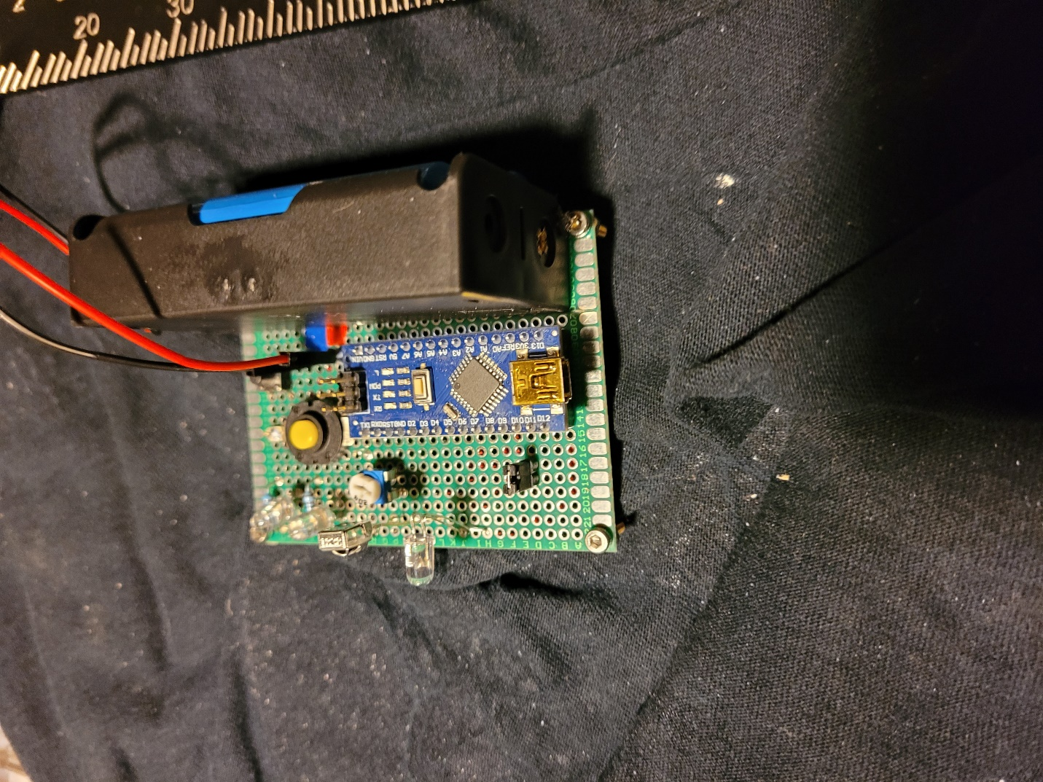

Pic 2

The placement of elements in Mouse Sim corresponds with the element placement in Fig. 1. In other words, IR Sensor in the Mouse Sim lines up with IR LED in the Beacon ( and IR Sensor in Beacon lines up with IR LED in Mouse Sim—for Option 2). The Mouse Sim IR LED trim pot is set to 7K Ohms.

2 short videos show the detection and extinguishment of the IR Beacon. The first video shows Option 1 and the second shows Option 2.

<https://drive.google.com/file/d/1QBdqIvoypiuzt3v7Cc1_xO0IgFIWmOQo/view?usp=sharing>

<https://drive.google.com/file/d/1mdNtVTnUxuk3f1_ImSzhdDCnsDkyYYGW/view?usp=sharing>

Recall that the Beacon is extinguished when its RED LED TURNS OFF and GREEN LED TURNS ON. Recall also that the Mouse Sim boards’ lights go from BOTH LED OFF thru RED ON to GREEN ON.

For Option 1, the RED LED ON is not seen due to the high speed of the response of the IR LED of Mouse Sim.

In either Option, when GREEN LED ON the Mouse Sim “knows” the Beacon is extinguished and then calls a routine (supplied by the competing team) to return to maze Start.

An example of a simply-connected 8 X 8 maze which will be used in the 2025 Cheese Hunt Competition, is shown below.

